Long Text URL POC

*Disclaimer: There is no proper error handling / test code in the sample codes. It is recommended to have these for production implementation.*

In this design, under the condition of that the Image Source of CC Promotion is set to “URL” and the Image URI is empty/blank, it picks up a value of Long Image URI.

## 1. Create custom object field, say Long_Image_URI__c here from Object Manager for CC Promotion object. The data type is Long Text Area.



## 2. Create a promotion service override and include the Long_Image_URI__c field into map by getFieldsMap method. Also replace imageURI field with this Long Image URI in prepReturn method which calls setLongURL function. Name the service logic class as ccMyPromotionService.

*/**  
 *  
 * Created by Noriko Goto  
 * Copyright 2019 CloudCraze Software, LLC. All rights reserved.  
 * Redistribution and use in source or binary forms, with or without  
 * modification is PROHIBITED.  
 *  
 */*global with sharing class ccMyPromotionService extends ccrz.ccServicePromotion {  
  
 global virtual override Map<String, Object> getFieldsMap(Map<String, Object> inputData)  
 {  
  
 ccrz.ccLog.log(System.LoggingLevel.DEBUG,'M:E:ccMyPromotionService:getFieldsMap');  
  
 inputData = super.getFieldsMap(inputData);  
 String objectFields = (String)inputData.get(ccrz.ccService.OBJECTFIELDS);  
 objectFields += ',Long_Image_URI__c' ;  
  
 ccrz.ccLog.log(System.LoggingLevel.DEBUG,'M:X:ccMyPromotionService:getFieldsMap:objectFields',objectFields);  
  
 return new Map <String,Object> {ccrz.ccService.OBJECTFIELDS => objectFields};  
 }  
  
 global virtual override Map<String, Object> prepReturn(Map<String, Object> inputData){  
 setLongURL(inputData);  
 ccrz.ccLog.log(System.LoggingLevel.DEBUG,'M:X:ccMyPromotionService:prepReturn');  
  
 return super.prepReturn(inputData);  
 }  
  
 public void setLongURL(Map<String, Object> returnMap) {  
  
 List<Map<String, Object>> promotionList = (List<Map<String, Object>>) returnMap.get(ccrz.ccApiPromotion.PROMOTIONLIST);  
  
 for(Map<String, Object> promotion : promotionList) {  
 String longImageURI = (String)promotion.get('longImageURI');  
 String imageURI = (String)promotion.get('imageURI');  
 String imageSource = (String)promotion.get('imageSource');  
  
 if(imageSource == 'URI' && String.isBlank(imageURI)) {  
 promotion.put('imageURI', longImageURI);  
 }  
 }  
 ccrz.ccLog.log(System.LoggingLevel.DEBUG,'M:X:ccMyPromotionService:setLongURL:returnMap',returnMap);  
 }  
}

Also refer to “Service Provider Example: Implementing ccServiceFoo” for more information around this topic. <https://cloudcraze.atlassian.net/wiki/spaces/CCRZDOCS48/pages/376243710/Service+Provider+Example+Implementing+ccServiceFoo>

## 3. Go to CC Admin and change the name of the promotion service to use. Make sure that the service class name has c. prefix on - c.ccMyPromotionService



## 4. Create and activate a new configuration cache.



## 5. Create a test data and load the landing page from the storefront.



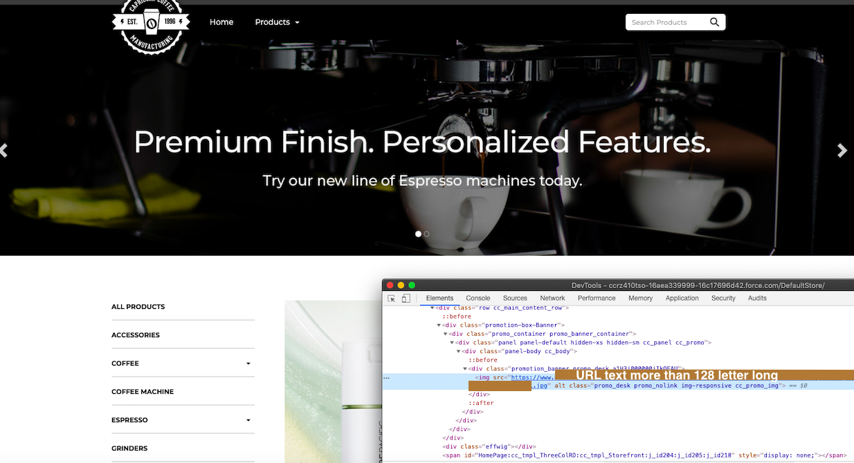

# Debug Tips

1. Set a logging Token from store setting.

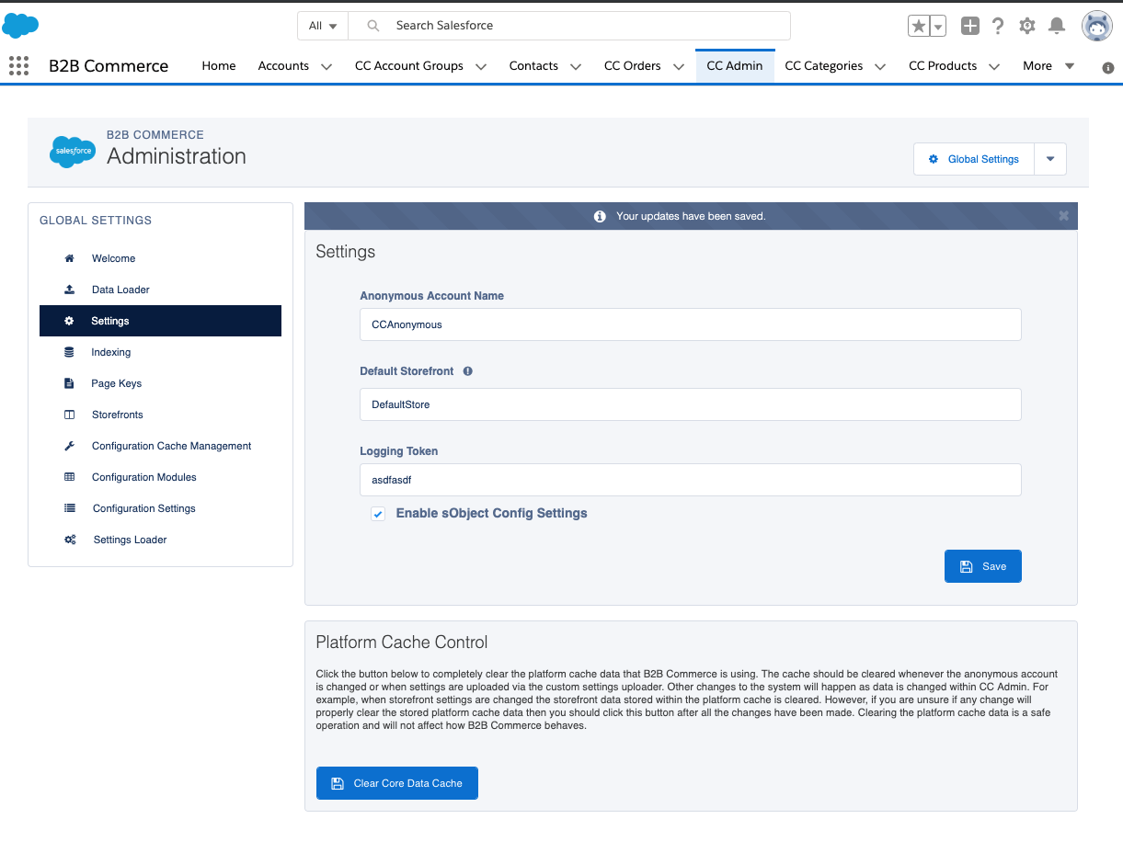

2. Add the token you set on the previous step into *ccLog* parameter in the URL.

[https://yourdomain/DefaultStore/ccrz__HomePage**?*ccLog=asdfasdf***](https://yourdomain/DefaultStore/ccrz__HomePage?ccLog=asdfasdf)

3. Go to the storefront and right click to choose inspect and open up the Developer Console (Chrome Browser).

4. Observe console window and find debug messages. “M:X:ccMyPromotionService” line will tell the outcome of the value conversion between imageURI and longImageURI.

